USER MANUAL

1. This application requires a smart phone running on android platform having a front facing camera.
2. Copy and paste this application in any directory of your smart phone.
3. Locate the application .apk file in the mobile.
4. Install it using the install option.
5. If a warning sign is shown to verify the app by google, go to mobile settings then go to security and select install from unknown sources option.
6. Now while the application is installing you should have the internet on.
7. If no internet was connected then application would install but would not be able to download the required libraries from google play service.
8. The libraries are required for the application features to work.
9. We can also connect to the internet later on to download these libraries.
10. This downloading is done in the background and you won’t notice it.
11. After the libraries are downloaded all the functionality of the application would work.
12. Now while running the application you have to keep your face in front of the front camera so that the camera could locate your face.
13. When you see a rectangular box made on your face on the screen this indicates that your face is being tracked.
14. Now blink your eyes normally.
15. The eye blink count will be displayed in the center of the rectangular box.
16. Other values you can see on the screen are the eye open probability of each individual eye.

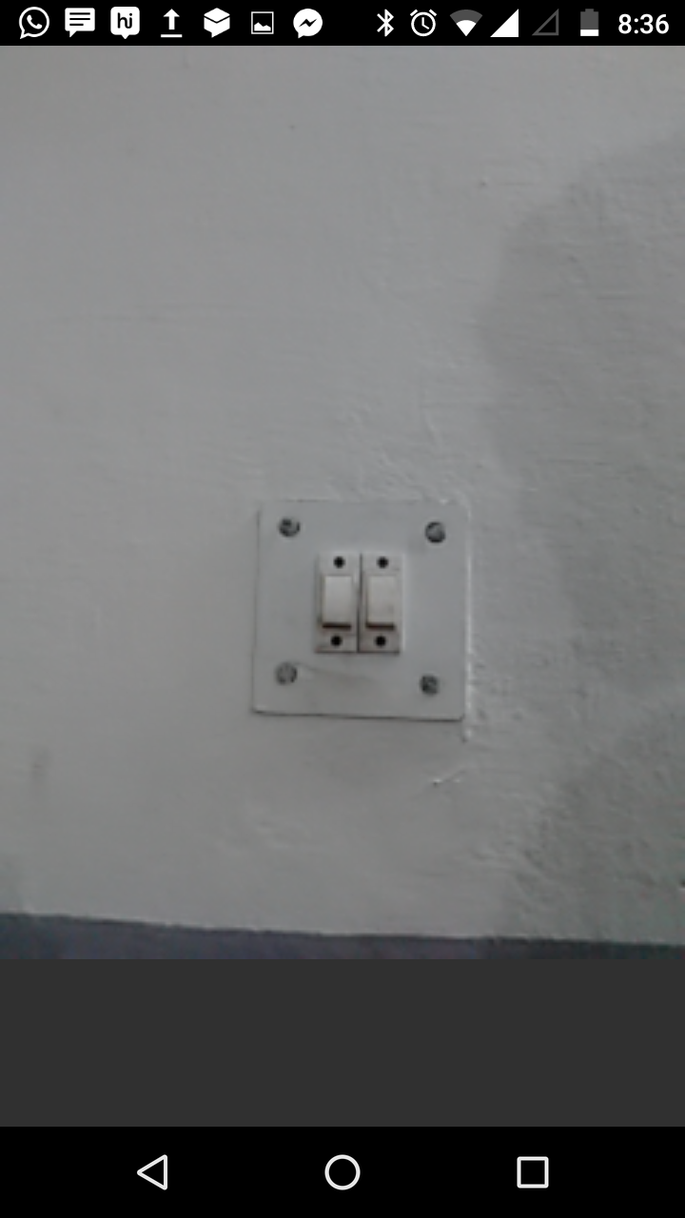

This is the screen you would see when you open the app,

i.e. Front Camera live Feed.

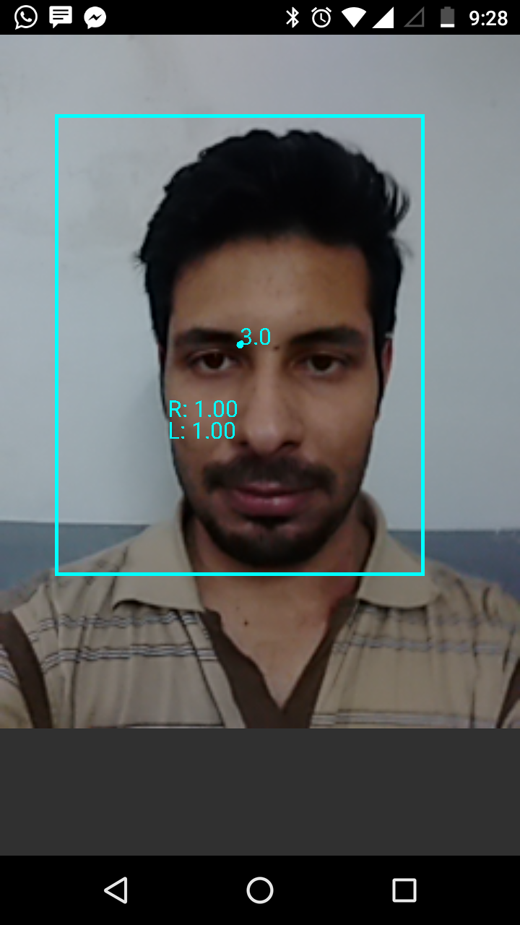

Running application.

The center value 3 is the count of the eye blinks.

Values 1 (L&R) are the eye open probability.